Patient information booklet

Sean O’Leary FRCS (Tr & Orth)

Osteotomy

High tibial (valgus) osteotomy
and
Distal femoral (varus) osteotomy

Date issued: 23 March 2009
Version 1.0

Introduction

Osteoarthritis (“wear and tear”) often affects one side of the knee joint more than the other – a unicompartmental arthritis – and can result in knee pain and deformity. When non operative measures - painkillers, anti-inflammatory drugs, Chondroitin / Glucosamine, physiotherapy, exercise programmes, weight loss - have not been successful in controlling the pain a major surgical procedure such as a joint replacement or an osteotomy is usually indicated.

When there is unicompartmental arthritis realignment osteotomy can ‘off load’ the affected compartment of the knee and move the body weight onto the healthier side of the knee. This procedure will ‘preserve’ the joint surface, maintain bone stock and avoid the restrictions which accompany joint replacement. It does not preclude any future surgical procedure such as partial or total joint replacement and is often thought of as ‘buying time’ for the knee.

Total knee replacement (TKR) and unicompartmental knee replacement (UKR) are frequently performed procedures - 78,000 TKRs in Eng & Wales 2008 - and largely successful with approximately 80% of patients being happy with their result following total knee replacement (UK National Joint Registry). However a joint replacement will have a ‘lifespan’ which will be reduced in younger, more active patients. In addition post operative constraints to activities such as running and heavy manual working may not suite the more active patient. Total joint replacement also involves the removal of some of the healthy bone stock and dividing at least one of the major knee ligaments. Revision joint surgery is possible for the ‘failed’ joint replacement but each time this takes place the outcome is less satisfactory both in terms of function and complications.

On the following pages I cover the reasons for your current symptoms, the potential benefits of having an osteotomy, the risks involved and what to expect after the procedure.

Knee anatomy & the problem

The knee joint is formed by the lower end of the thigh bone (the femoral condyles) and the upper surface of the shin bone (the tibial plateau). The joint is divided into two halves or compartments – the medial (inner) and lateral (outer) compartments. A smooth substance - articular cartilage - normally covers the surface of these bones and minimises friction and weight transmission to the underlying bone.

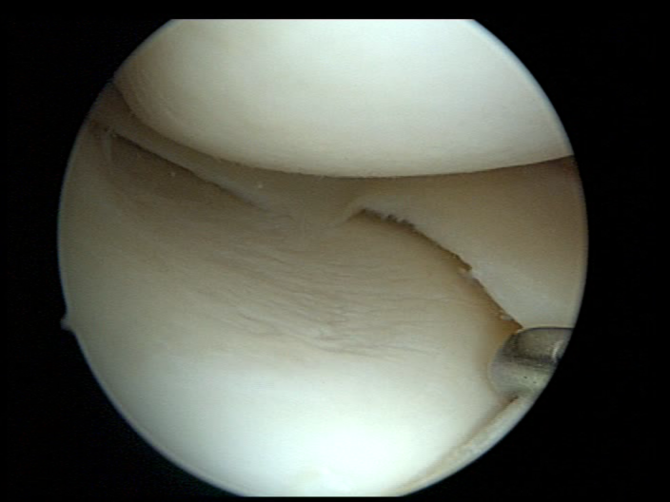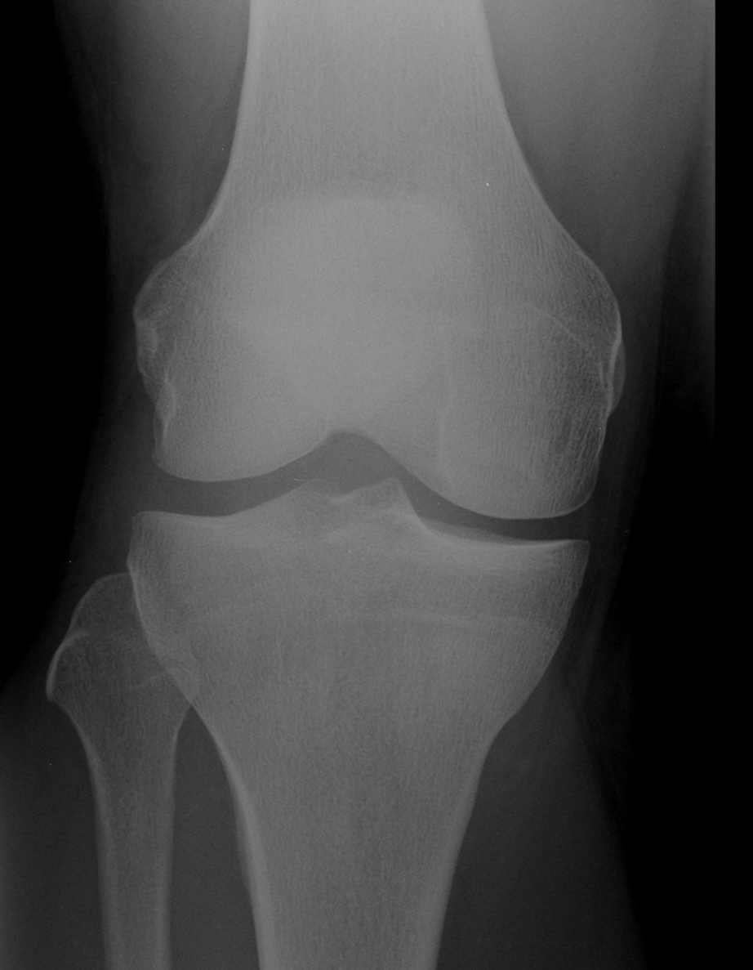

Normal articular cartilage and meniscus Normal x-ray

Osteoarthritis (OA) is the direct consequence of this articular cartilage thinning and eventually exposing the underlying bone. OA is strongly associated with age and genetic (hereditary) factors but could also be the result of previous injury (fracture or other), previous surgery (meniscectomy), previous infection or coexisting inflammatory joint conditions.
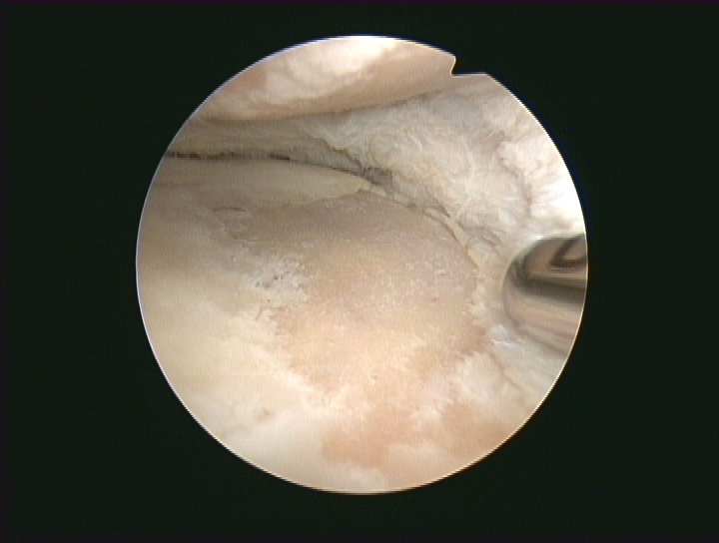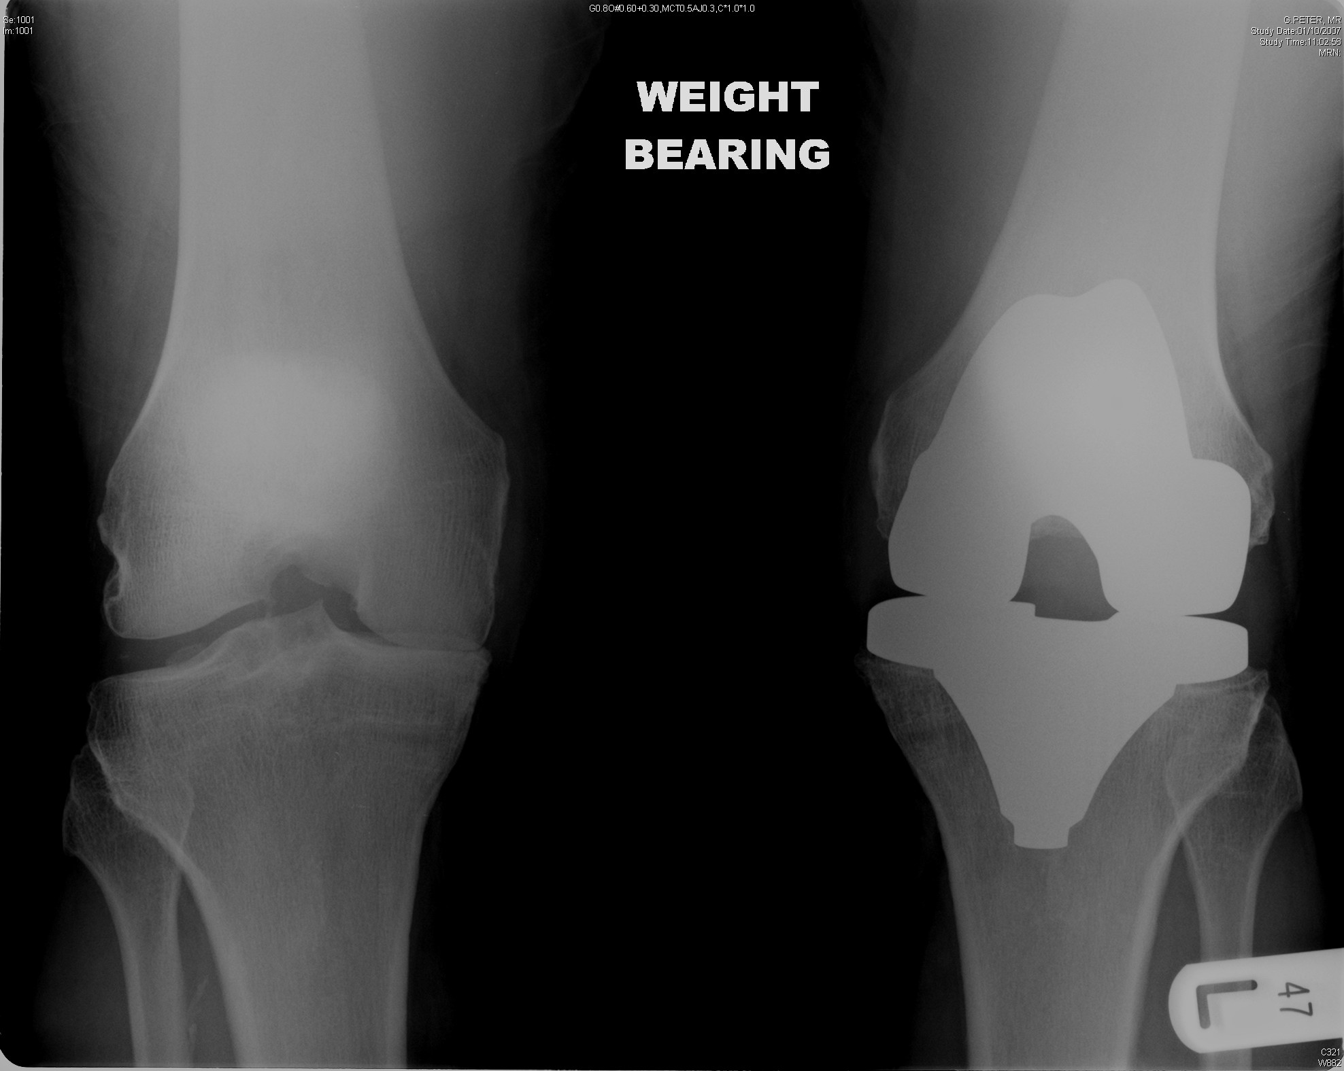

Exposed bone Torn resected meniscus ‘Healthy’ Bone on bone
(“Bone on bone”) joint space
When standing or walking (‘weight bearing’) the force is transmitted from the centre of the ankle to the centre of the hip (femoral head). This ‘weight bearing line’ (mechanical axis / alignment) will pass through the knee – usually through the centre or just on the inner side of the midline. However not everyone is ‘made the same’ and there is great variability in what we may consider to be normal for each individual.

When the articular cartilage and bone wears away from the medial or lateral compartment - causing bowleg (varus) or knock knee (valgus) deformities - it will result in a change of this mechanical axis. This in turn will lead to more of the body weight being transmitted through that affected compartment, overloading the underlying bone causing changes in the structure of the bone and pain.

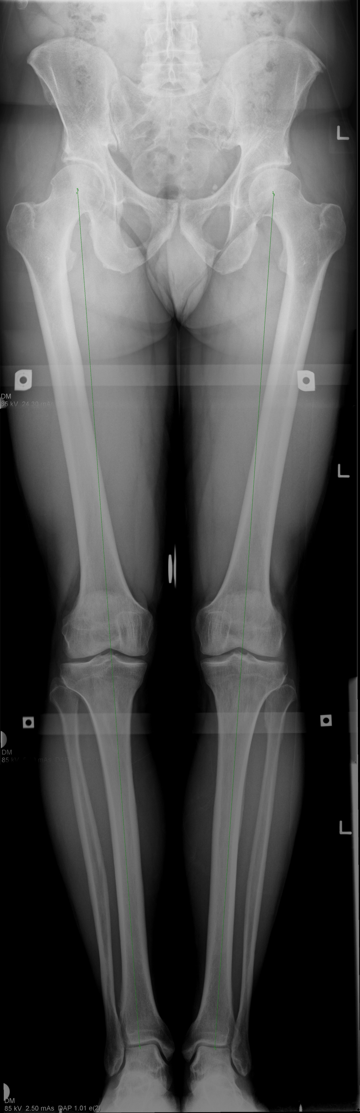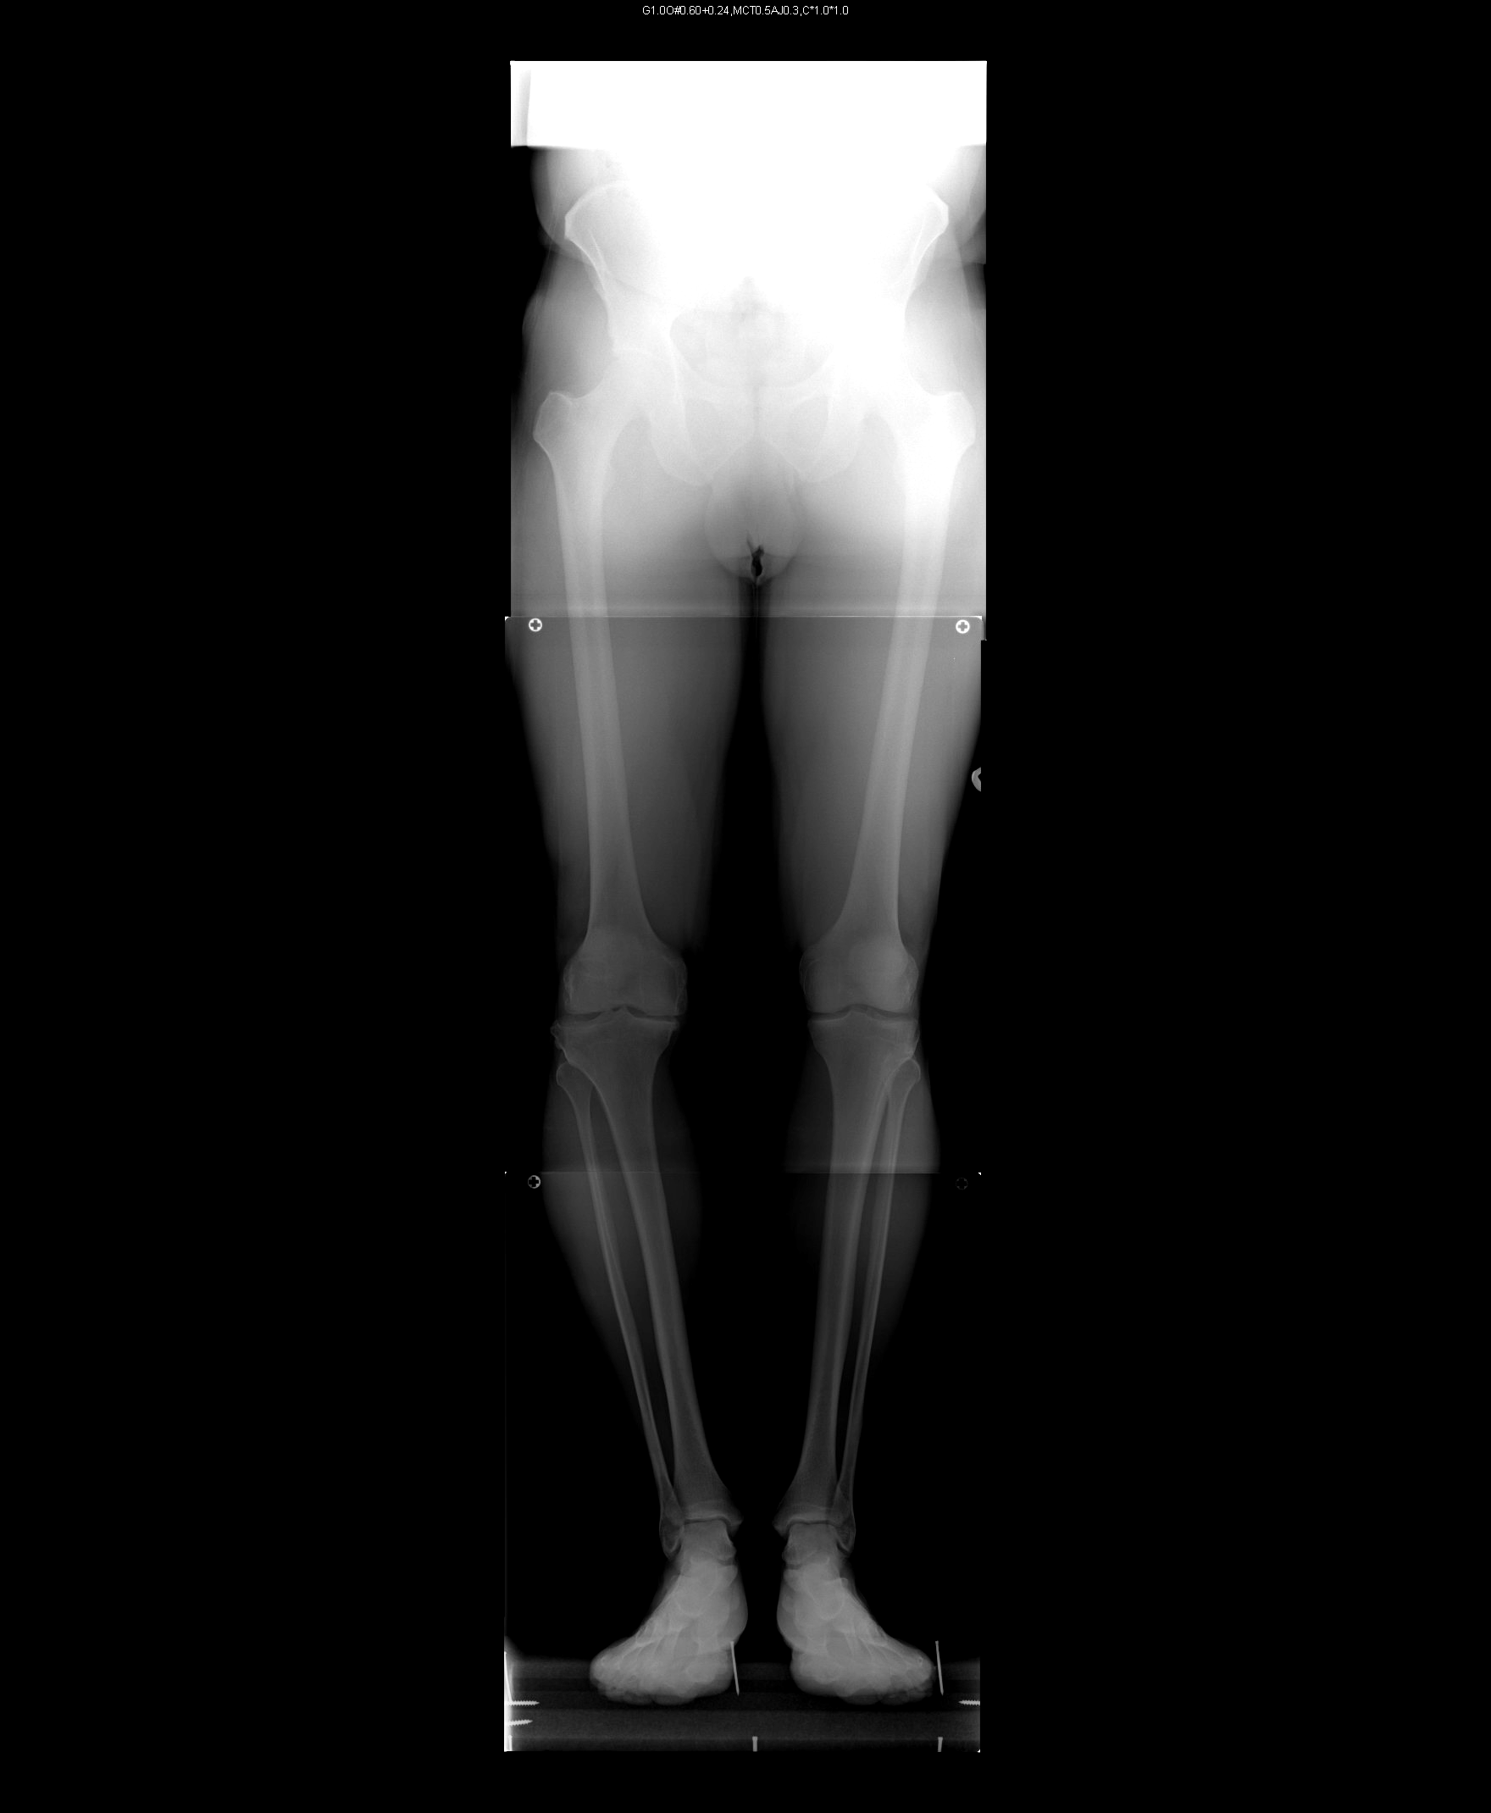
• • •
‘Normal’ alignment Varus alignment

This malalignment will (or should) be corrected when performing a total or partial joint replacement but ‘joint preserving’ procedures such as osteotomy are usually a preferable alternative in younger, more active patients.
Osteotomy - General Information

There is no evidence that leaving an arthritic knee without surgery puts it at any particular risk but it is likely the pain and deformity may worsen with time.

An osteotomy does involve cutting - and then fixing - the bone which implies that the ‘fracture’ will need to heal. This healing is significantly reduced in patients who smoke and this procedure is therefore not recommended for patients who are smokers.

Osteoarthritis is sometimes the long term consequence of previous injury involving the major knee ligaments. The ligaments stabilise the knee and therefore arthritis can sometimes be associated with instability or giving way. Osteotomy can in some cases – by changing the shape of the upper surface of the shin bone (tibia) – improve the stability of the knee as well as offloading an arthritic compartment.

Arthroscopy (key hole surgery) is still sometimes used to fully assess the extent of the arthritis in the knee joint. This information will help the surgeon decide which major procedure is appropriate.

The aim of an osteotomy is to reduce pain and improve function. It may not produce complete relief of pain but it should significantly improve the pains from that compartment of the knee.

For the best long term results it is suggested that the deformity is overcorrected - resulting in a mild knock knee (valgus) appearance. Some patients may find this unacceptable.

Pre operative exercise(s)

Besides the general health and wellbeing aspects of fitness, patients who already have good muscular strength and control will find the post operative recovery easier. Exercises which are recommended are those ‘lower impact’ activities such as cycling, rowing and the cross trainer.

Anaesthesia / Pain management

Having an osteotomy will usually require a general anaesthetic i.e. ‘completely asleep’. This will be discussed on the morning of your surgery by the anaesthetist as will appropriate measures to reduce any post operative discomfort. At the time of your anaesthetic intravenous antibiotics will also be given to reduce the risk of infection.

Surgical wound

Following anaesthesia a tight inflatable band (tourniquet) is applied to the upper thigh to restrict the bleeding during the procedure. The surgeon will make a longitudinal incision at the side of the tibia or femur which will later be closed with stitches or clips. A drain will be inserted into the wound to collect any blood which may accumulate. This is removed the day after your surgery. The stitches or clips will need to be removed 10 -14 days after your operation and can be done at your local surgery. You will be able to shower whilst the stitches or clips are still in situ.

When should an osteotomy not be done?

- Smokers
- Signs of arthritis or previous excision of cartilage from other joint compartment
- Inflammatory joint disease
- Significant patello-femoral / anterior knee pains
- Stiff knees
- Knees with ‘significant’ deformity

How is an osteotomy done?

There are two main techniques of realigning the knee joint. Both involve cutting the bone above or below the knee with a saw using x-ray guidance. The ‘fracture’ is then stabilised with a plate and screws. The pre operative planning of the osteotomy is the key to the success of this procedure. This is done with the aid of computer software and uses measurements taken from the ‘long leg’ x-ray you will have had done. This will help determine which type of osteotomy you will require and how large a correction will be necessary at the time of surgery.

Closing wedge osteotomy

This involves two bone cuts to remove a wedge of bone either from the tibia (shin bone) for bowleg deformity or femur (thigh bone) for knock-knee deformity. Subsequently the ‘fracture gap’ is brought together and held in position with staples or a plate and screws.

Opening wedge osteotomy

After the bone cut is made the two sides of the ‘fracture’ are separated by a pre determined angle to form a wedge-shaped opening. The osteotomy is then stabilised with a plate and screws. Small corrections do not require bone grafting but larger corrections may be filled with bone graft from the patient (usually from the hip), sterilised bone chips or a synthetic wedge of ‘calcium based’ material.

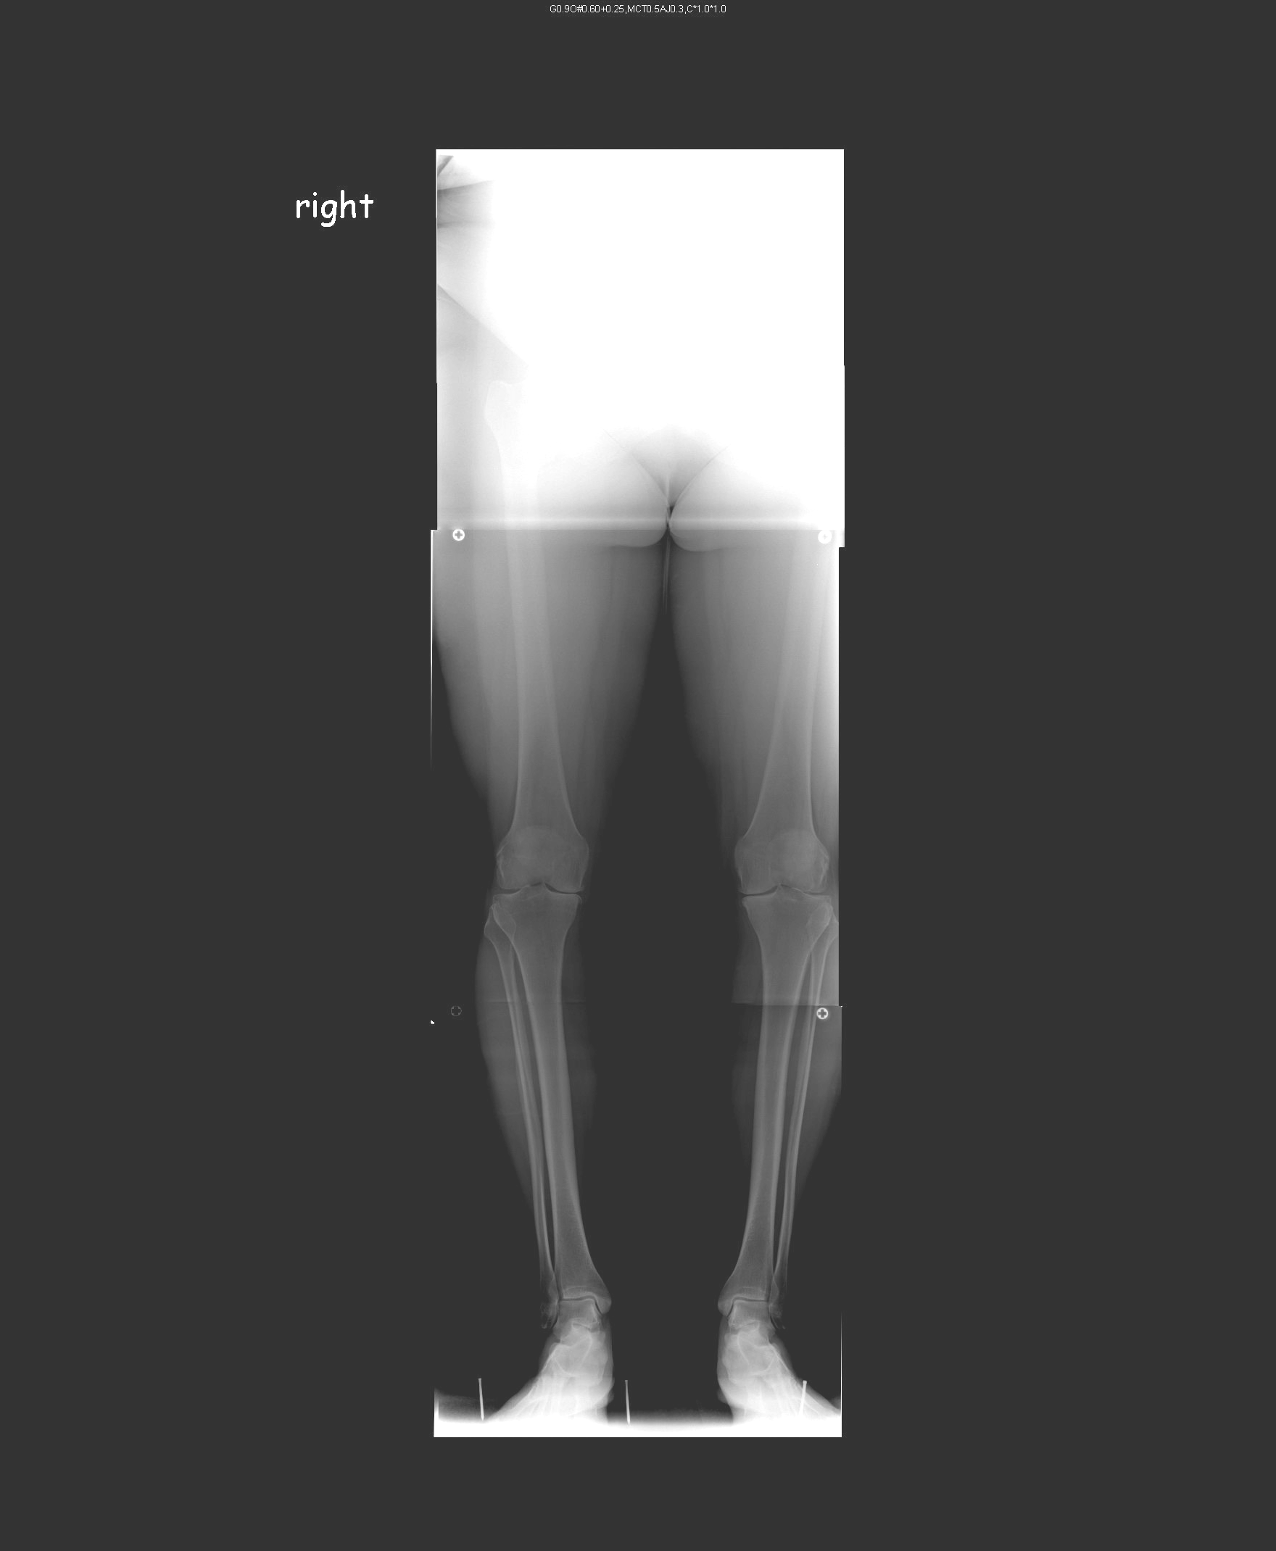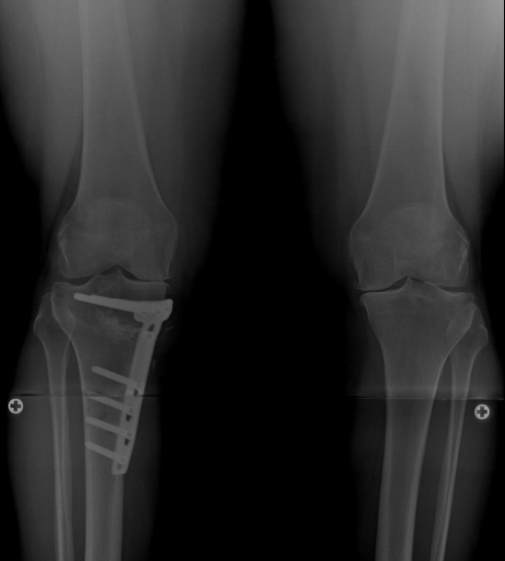
• •
Varus After
deformity osteotomy
Risks and potential complications of an osteotomy

- Post operative bleeding
A suction drain is used to collect any bleeding but some bruising will still occur. If a collection (haematoma) results it may need to be drained.
  - Altered wound healing / sensation
Most heal well but the wound may become red, thickened and painful (keloid) – more common in the Afro-Caribbean race. Damage to the small skin nerves can result in some temporary or permanent alteration of sensation to the skin on the front of the knee.
- Wound infection
Despite the routine use of antibiotics infections may still occur. Another operation may be required to wash out the infected wound and - if involved – the metalwork may need to be removed and replaced at a later stage.
- Removal of the metalwork
If the plate becomes palpable / causes discomfort it may need to be removed when the osteotomy has healed. This may also be recommended even if not causing symptoms.

Approx. 1-5 in 100 patients

- Blood clots (Deep Vein Thrombosis / Pulmonary Embolism)
Following all major lower limb surgery there is a risk of forming a blood clot in the calf (DVT). These can occasionally break off and move through the blood stream to the lungs (pulmonary embolus). A large pulmonary embolism may be fatal (3 in 1000 cases of total knee replacement). You will be given treatments to reduce this risk - calf compression device and heparin injections. Early ankle movements and mobilisation are also important factors.
- Delayed healing / ‘non union’ of the bones
Sometimes the two bone edges do not unite (heal together) as planned - a non union. Smoking significantly impairs bone healing and this procedure is not therefore recommended for those who smoke. This usually requires a further operation.
- Intra articular fracture
A fracture into the knee joint may occur which will require additional fixation.

Approx. 1-5 in 1000 patients

- Compartment syndrome
Post operative bleeding into the calf muscles may cause an increase in pressure and significant pain. This requires an emergency procedure to release the muscle compartments under pressure. The wounds are usually left open and may require skin grafting at a later stage.
- Damage to the major nerves around the knee
Very rarely the larger nerves around the knee can be involved resulting in temporary or permanent weakness and/or altered sensation.
- Damage to the blood vessels behind the knee
This can lead to loss of circulation to the leg and foot. If this happens you will need immediate surgery to restore the blood flow and could result in amputation.

After your operation

You will have no splints, braces or plaster on your leg after the surgery. The stability will be provided by the rigid fixation of the plate and screws. You will be encouraged to regain a full range of extension (straightening) and flexion (bending) as soon as possible after the operation and to begin some strengthening exercises when comfortable.

Your physiotherapist will show you some general exercises to perform to aid your early recovery and mobility and may give you a booklet to take home with you.

You will be able to weight-bear as comfort allows on the day following surgery and your physiotherapist will also help you with this.

Most patients can go home on the day following surgery as long as:

- the pain is under control and a plan has been established for reducing analgesia at home
- you are able to get in and out of bed
- you can walk confidently using your crutches to access the bathroom

Uneventful recovery from an osteotomy may take 4 to 6 months. As the osteotomy heals you will feel less pain and more confident when walking. You will have an x-ray at 6 weeks and 3 months to assess the bone healing. When you are safe putting full weight through the leg several types of balance exercises can be chosen to further control and stabilise the knee.

Cryocuff

If you have been provided with this cooling device, it can be taken home and put into the fridge / freezer to help with pain control. If not ice packs will substitute.

Crutches / Mobilisation

Typically you will need crutches for 4 to 6 weeks but will be full weight bearing before 6 weeks if all goes to plan.

Eating and drinking

Following your operation you may feel nauseous - a common symptom following surgery and a frequent side effect of pain-relieving drugs. If severe, medication can be given to help improve this.

Driving

Usually not for 6 weeks following this major procedure but this will depend on comfort and confidence when walking / moving.

Sex

As able when comfortable although kneeling may be difficult for the first few weeks.
Sports

Research indicates that only a few individuals are able to return to their previous high level of sports activity following an osteotomy – whether or not an ACL reconstruction is done at the same time or not. However most are able to return to leisure sports activities such as walking, hiking, cycling, swimming, tennis. Contact sports and distance running are not recommended although the patient should ultimately be guided by how they feel about their own knee.

As long as the osteotomy heals and there are no other complications swimming and gentle cycling / rowing may be commenced at about 3 months. There are no restrictions but it may be 6 to 9 months before vigorous sporting activity can be resumed.

What are the results?

Osteotomy has been performed for arthritis for centuries and many surgeons have reported their results. But the variety of techniques used, different methods of recording results and small numbers involved in each study have meant that there is still no consensus regarding certain aspects of this surgery. The question of ‘what is success’ has not been answered and ‘failure’ is commonly accepted as the time at which a joint replacement if finally done. Little comment has been made on the quality of those ‘added years’ before joint replacement.

However two factors are consistently recognised as being very important:
- Appropriate patient selection
- Quality surgical technique.

Regarding patient selection it is generally acknowledged that the best results are seen in:
- patients under 60 years
- smaller deformity i.e. relatively early in the arthritic process
- Unicompartmental disease
- Stable ligaments
- A good pre operative range of motion (greater than 90°)
- No inflammatory joint disease
- No significant patello-femoral (anterior knee) pain

Regarding surgical technique the introduction of planning software has improved the accuracy of the operative correction and this may still be improved further with the introduction of ‘computer aided’ surgery.

Poorer longer term survival is seen with:

- Under correction of the deformity
- Penetration of the joint / intra articular fracture

The success (survival) of the operation varies between reports but approximately 90% of patients will definitely last 5 years. Thereafter the survivorship depends directly on the accuracy of the post operative correction which is determined by further long leg x-rays. If a sufficient correction was achieved at osteotomy and symptoms (pain) increase with time then a joint replacement will be the only surgical alternative.

Results range from 45 to 80% survival at 10 years. Under correction was associated with higher revision rates whereas neutral or overcorrection has results which rival the survival of joint replacements.

